2022 FSR Technical Conference
Announcement
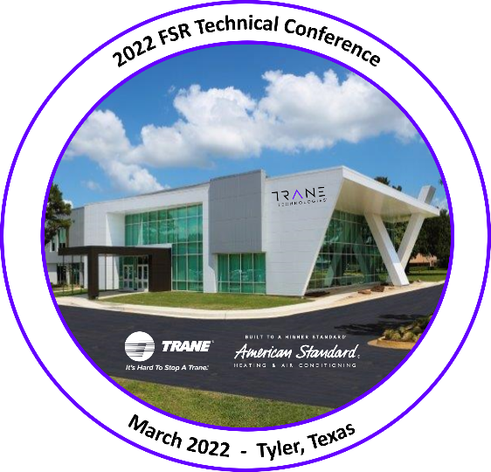

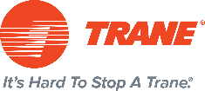

The RS Technical Support Team is excited to announce the 2022 FSR Technical Conference!

In March, the Technical Support team will welcome Trane and American Standard Field Service Representatives to the Tyler factory for a long-awaited Technical Conference.

The 2022 FSR Technical Conference is unique in that the week-long curriculum will be delivered three times, in three Conference Sessions, during the month of March. This affords alignment with current health and safety protocols while simultaneously allowing more FSR’s to attend without any sacrifice to their local dealer support.

FSR participants for each session are limited to a maximum of sixty (60) FSR’s.

A comprehensive curriculum, with focus on the new LINK communicating platform and the SYMBIO Light Commercial controls system, will be delivered across five full days for each session of the conference. Many more topics are included in the agenda to enhance FSR support capabilities including Advanced EEV and Defrost Diagnostics, ECM Motor Programmers (including new motor programmer), FSR Training Best Practices, Home Diagnostics, FSR Software Tools, Ductless, and more.

Field Service Representatives can register for a Conference Session through the link below:

Click Here to Register!

2022 FSR Technical Conference

Please join us for the 2022 FSR Technical Conference
There are a limited number of seats (60) available for each session.

Conference Session Schedule:
Session 1:
February 28 – March 4, 2022
8am – 5pm (Monday – Friday)

Session 2:
March 14 - 18, 2022
8am – 5pm (Monday – Friday)

Session 3:
March 28 – April 1, 2022
8am – 5pm (Monday – Friday)

Training Location:
Tyler Facility
6200 Troup Highway
Tyler, Texas 75707

Agenda Topics:
LINK Communicating Platform, SYMBIO LCU Controls, ECM Motor Programming, Advanced EEV and Defrost Diagnostics, Home Diagnostics, FSR Software Tools, FSR Training Best Practices, Ductless, and more.

Attire: Business Casual. No ‘open-toe’ footwear.

How to sign up? Registration Website Click Here to Register!

Air Travel & Ground Transportation:
Each attendee is responsible for making his/her own airline and hotel arrangements. Attendees may rent cars, however, there will be a bus that will transport attendees to the Tyler Facility and back to the Residence Inn each day for class.

