**Subject: Coming Soon: A new look when logging in to [ComfortSite/ASDealerNet]**

Beginning [date], logging in to [ComfortSite/ASDealerNet] will look a little different. You will see a screen that prompts you to enter your “Sign In” ID and password (see below). **Your ID and password are the same credentials that you would normally use to sign in to** [ComfortSite/ASDealerNet]**.**

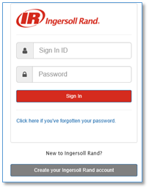

**After entering your Sign In ID and password,** [ComfortSite/ASDealerNet] **will open and perform as usual.**

**Why is this happening?**

We are replacing the current [ComfortSite/ASDealerNet] login process with a digital security tool that will simplify your user experience and allow you to reset your password without having to call or email the customer service team.

If you have any questions, please contact the Dealer Order Management team at 800-430-5284 or [support@ComfortSite.com](mailto:support@ComfortSite.com) or [support@ASDealerNet.com](mailto:support@ASDealerNet.com).

Thank you,